Saccade Analyser

## SACCADE DETECTION

State Machine – detects saccades point-by-point, could potentially be dropped into a real-time system. Note: peak acceleration must be greater than a dynamic threshold which is defined as a multiple of the average acceleration within the last n seconds (default 20 ms) or some minimum.

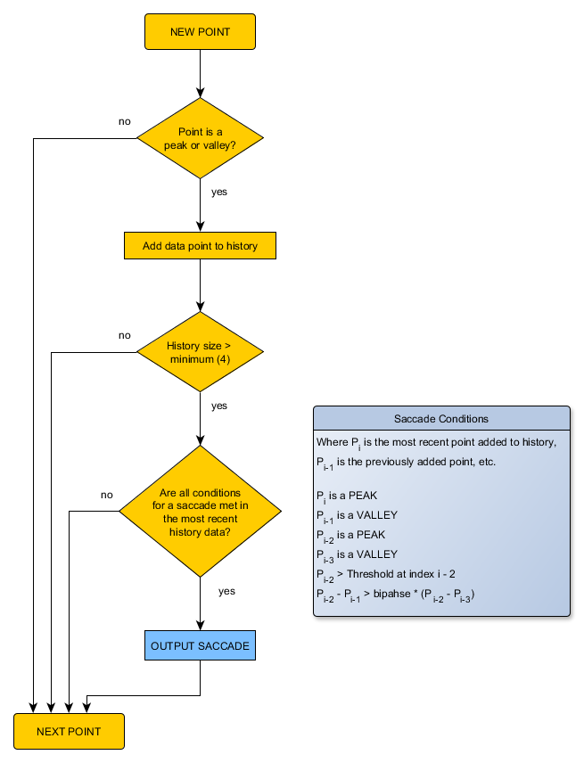

Saccade Acceleration Characteristics:

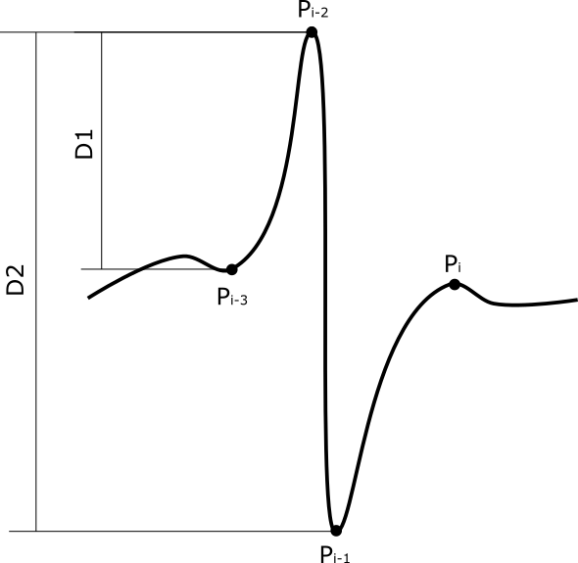

**Detection Parameters:**

Running Stat Time – window size to use when calculating the dynamic acceleration threshold

Acceleration Min – minimum dynamic acceleration threshold

Acceleration Multiplier – multiplier to use when calculating the dynamic acceleration threshold

Biphasic Condition – multiplier used when comparing distances D1 and D2, used to filter out accelerations which are not symmetric (e.g. ordinary impulse onset).

## Gain Calculation

The saccade analyser can estimate VOR gain from data just prior to detected saccades. It calculates gain per saccade as the median of eye velocity / head velocity within the window beginning “Onset Lead” ms prior to saccade onset and with a specified Duration. By default:

* Onset Lead = 40 ms
* Duration = 30 ms

Gain calculations are only included when this window falls within a valid portion of the stimulus impulse. This is defined as a % of half the impulse beginning at peak and working back towards onset. This is defined by the “Valid Pre-Peak %” parameter which by default is 50%. This then accepts gain calculations whose windows fall between impulse peak and half way back to impulse onset.